**HSC EOA Documentation**

Contents

Data Source 2

Main Components of the “Schedule” tab 2

Logic of Main Table 3

Slicer 3

EOA Year Color 4

Shelter Occupancy Revenue 4

Shelter Expenses 5

Capital Reserve Fund (CRF) 9

SUBSIDY REVENUE 11

Accumulated Surplus (Deficit) 12

Existing control panel options 12

Logic for variability rating 13

Question from us 14

# Data Source

1. “IPT_DataX” tab: Main data source for EOA
2. “CRT_DX_OTT” tab: Data source for Asset Planner calculation

# Main Components of the “Schedule” tab

We can divide the schedule tab into following components:

1. **Advanced setting control**: User can change the setting here which can link to the calculation of the line items in the main table.

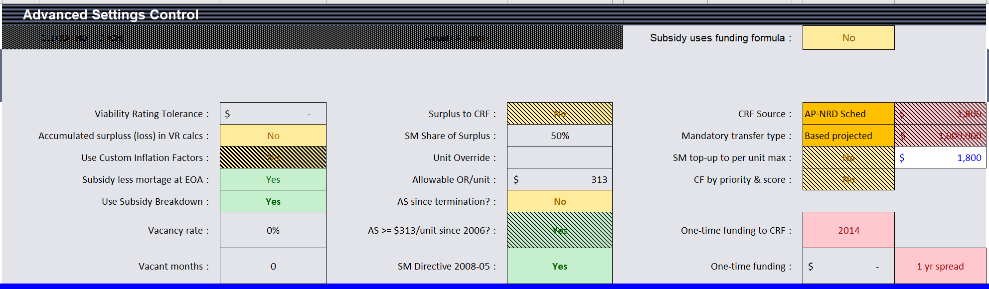

1. **Variability Assessment**: This area is to assess the project variability on different year (project started year, current year and EOA range), rating will be assigned after evaluating the net income(loss) and end balance for capital reserves

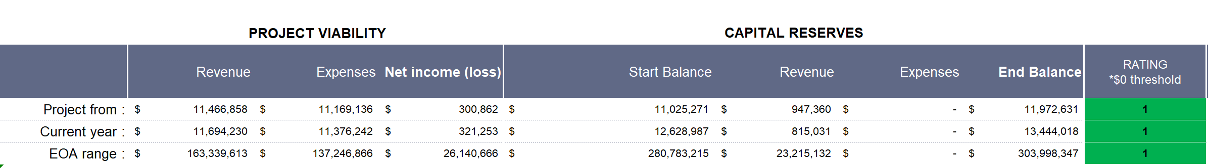

1. **Adjusted input** if applicable: This area is for users to override the current data/index if necessary. In all the formulas of the main table, the value of the line items for the base year can be modified here.

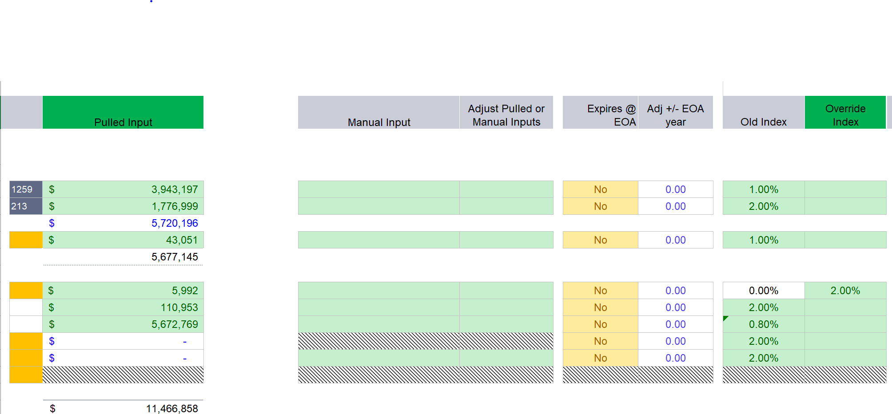

1. **Operating Reserve Calculations (AIR Method)/Surplus Repayment/General Subsidy**: This table is hidden in the schedule tab (row 119 to row 275). The main purpose is to calculate the “contribution from 50% surplus” for the capital reserve fund through all the relationship and logics within this section.

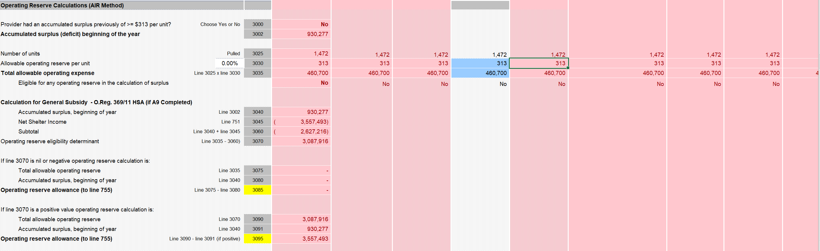

1. **Main table**: This table includes Shelter Revenue, Shelter Expense, Capital Reserve Fund, Subsidy Revenue, Accumulated Surplus and end balance of each year.

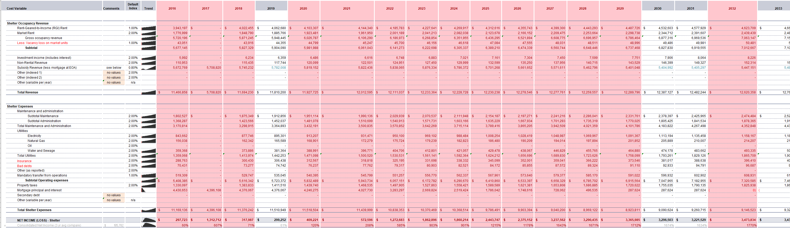

# Logic of Main Table

## Slicer

1. Project Sponsor/Project name/Project address/Program Type/Debt retire date (EOA)/Client type: These slicers will link to the filters of the pivot tables with data source “IPT_DataX”.

We have to determine what are the slicers need to be included in the new version.



1. Asset Priority/Priority Score: These two slicers are only available when clients purchase the service of “Asset Planner”. They will link to pivot tables with data source CRP_DX_OTT”.

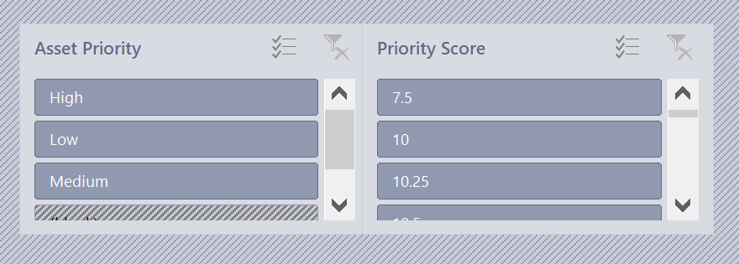

## EOA Year Color

In the table, the color will be assigned to the year column based on the following order:

1. If the year is falling within the EOA range (Red)
2. If the year is current year (Yellow)
3. If the year is when project started (Green)

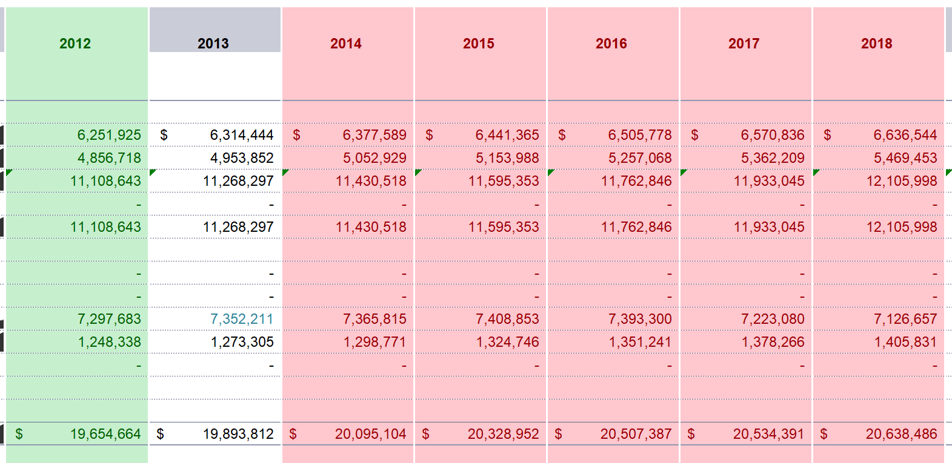

## Shelter Occupancy Revenue

1. Rent-Geared-to-Income (RGI) Rent: the amount for base year is the sum of the column “Current RGI rent revenue”. For the rest of year, it is calculated based on the following formula:

***Amount at base year *(1+default index)^(difference between the current calculated year and base year)***

1. Market Rent: the amount for base year is the sum of the column “market rent revenue”. For the rest of year, it is calculated based on the following formula:

***Amount at base year *(1+default index)^(difference between the current calculated year and base year)***

1. ***Gross occupancy revenue = RGI Rent + Market Rent***
2. Less Vacancy loss on market units: The amount for base year is the sum of the column “Vacancy loss on market units(if applicable) ”. For the rest of year, it is calculated based on the following formula:

***Amount at base year *(1+default index)^(difference between the current calculated year and base year)***

1. ***Subtotal=Gross occupancy revenue – vacancy loss on market units***
2. Investment income (includes interest)/Non-Rental Revenue: The amount of base year is the sum of the column *“Investment interest income”. For the rest of year, it is calculated based on the following formula:

***Amount at base year *(1+default index)^(difference between the current calculated year and base year)***

1. Subsidy Revenue (less mortgage at EOA): If user select “yes” for “Use Subsidy breakdown” in control panel, then subsidy revenue equals to sum of federal subsidy and municipal subsidy. Else, if user select “yes” for “Subsidy less mortgage at EOA”, then we will take the sum of the column “Current Subsidy Revenue” from raw data source tab “IPT_DataX”. For the rest of year, it is calculated based on the following formula:

***Amount at base year *(1+default index)^(difference between the current calculated year and base year)***

1. Other (indexed 1): The amount of base year is the sum of the column “Current other revenue”.

For the rest of year, it is calculated based on the following formula:

***Amount at base year *(1+default index)^(difference between the current calculated year and base year)***

1. Other (indexed 2)/Other (variables per year): These two are not used.
2. ***Total Revenue = Subtotal + Investment income (includes interest) + Non-Rental Revenue + Subsidy Revenue (less mortgage at EOA) + Other (indexed 1) + Other (indexed 2) + Other (variables per year)***

## Shelter Expenses

1. Subtotal Maintenance: The amount of base year is the sum of the column “Subtotal Maintenance”.

For the rest of year, it is calculated based on the following formula:

***Amount at base year *(1+default index)^(difference between the current calculated year and base year)***

1. Subtotal Administration: The amount of base year is the sum of the column “Subtotal Administration”.

For the rest of year, it is calculated based on the following formula:

***Amount at base year *(1+default index)^(difference between the current calculated year and base year)***

1. Total Maintenance and Administration: The amount of base year is the sum of the column “Current maintenance & admin. Costs”.

For the rest of year, it is calculated based on the following formula:

***Amount at base year *(1+default index)^(difference between the current calculated year and base year)***

1. Electricity: The amount of base year is the sum of the column “Electricity”.

For the rest of year, it is calculated based on the following formula:

***Amount at base year *(1+default index)^(difference between the current calculated year and base year)***

1. Natural Gas: The amount of base year is the sum of the column “Natural Gas”.

For the rest of year, it is calculated based on the following formula:

***Amount at base year *(1+default index)^(difference between the current calculated year and base year)***

1. Oil: The amount of base year is the sum of the column “Oil”.

For the rest of year, it is calculated based on the following formula:

***Amount at base year *(1+default index)^(difference between the current calculated year and base year)***

1. Water and Sewage: The amount of base year is the sum of the column “Water and Sewage”.

For the rest of year, it is calculated based on the following formula:

***Amount at base year *(1+default index)^(difference between the current calculated year and base year)***

1. Total Utilities: When the sum of Electricity, Natural Gas, Oil and Water and Sewage is 0 from previous line items, Total Utilities will take the sum of column “Current utilities”. For the rest of year, it is calculated based on the following formula:

***Amount at base year *(1+default index)^(difference between the current calculated year and base year)***

1. Insurance: The amount of base year is the sum of the column “**Insurance”. For the rest of year, it is calculated based on the following formula:

***Amount at base year *(1+default index)^(difference between the current calculated year and base year)***

Non

1. Bad debts: The amount of base year is the sum of the column “Bad debts (current reporting year or past 3-yr. avg.)”. For the rest of year, it is calculated based on the following formula:

***Amount at base year *(1+default index)^(difference between the current calculated year and base year)***

1. Other (as reported): The amount of base year is the sum of the column “Current other operating costs”. For the rest of year, it is calculated based on the following formula:

***Amount at base year *(1+default index)^(difference between the current calculated year and base year)***

1. Mandatory transfer from operations: The amount of base year is the sum of the column “Annual capital reserve deposit”. For the rest of year, it is calculated based on the following formula:

***Amount at base year *(1+default index)^(difference between the current calculated year and base year)***

1. ***Subtotal Operating expenses = Total Maintenance and Administration + Total Utilities + Insurance + Bad debts + Other (as reported) + Mandatory transfer from operations***
2. Property taxes: The amount of base year is the sum of the column “Current property Taxes”. For the rest of year, it is calculated based on the following formula:

***Amount at base year *(1+default index)^(difference between the current calculated year and base year)***

1. Mortgage principal and interest: The amount for this line item will take into consideration of columns “Debt retire date (EOA)” and “Current annual payments of primary” from data source “IPT_DataX”. The total of “Current annual payments of primary” will depreciate based on the payment amount of Debt retire year. For example, if the total of all annual payments of primary is 6,241,962, project started from 2012, but EOA range started from 2014. The mortgage principal and interest amount in 2014 will be 6,200,493 (6,241,962-41,469=6,200,493) as there was a payment of 41,469 happened in 2014. In 2015, there was a payment of 12,586, so the mortgage principal and interest in 2016 will be 6,187,907(6,200,493-12,586=6,187,907), subtracting the mortgage principal and interest from previous year by the current calculated year’s annual payment.
2. Secondary debt: The calculation of this line item is the same as “Mortgage principal and interest” and only applicable when we have second debt and users select “Yes” for “Expires @ EOA” under the Adjusted Input area. If sum of column “Current annual payments (of secondary)” is 0, this line item will 0 for all years.
3. Other (variable per year): Not used
4. ***Total Shelter Expenses = Subtotal Operating expenses + Property taxes + Mortgage principal and interest + Secondary debt + Other (variable per year)***
5. ***NET INCOME (LOSS) – Shelter = Total Revenue – Total Shelter Expenses***
6. ***Consolidated Net Income (3 yr avg compare) = (“NET INCOME(LOSS)-Shelter”- “Sum of Consolidated Net Income (Loss) from audited statements (past 3-year average)”) /Absolute value of “Sum of Consolidated Net Income (Loss) from audited statements (past 3-year average)”***
7. Gifts and donations: The amount of base year is the sum of the column “**Gifts and Donations”. For the rest of year, it is calculated based on the following formula:

***Amount at base year *(1+default index)^(difference between the current calculated year and base year)***

1. Non shelter revenue (net): The amount of base year is the sum of the column “*Non-shelter revenue (i.e. grants)”. For the rest of year, it is calculated based on the following formula:

***Amount at base year *(1+default index)^(difference between the current calculated year and base year)***

1. Sector support(net) (co-ops only): The amount of base year is the sum of the column “**Sector support (if applicable)”. For the rest of year, it is calculated based on the following formula:

***Amount at base year *(1+default index)^(difference between the current calculated year and base year)***

1. ***Non-Shelter Net Income (Loss) = Gifts and donations + Non shelter revenue (net) + Sector support (net) (co-ops only)***
2. ***NET INCOME (LOSS) – TOTAL = NET INCOME(LOSS) – Shelter + Non-Shelter Net Income (Loss)***
3. ***DSCR = (Total Revenue – (Subtotal Operating expenses + Property taxes))/Mortgage principal and interest***

DSCR refers to the amount of cash flow available to meet annual interest and principal payments on debt.

1. ***DSCR w/o Cap = (Total Revenue – ((Subtotal Operating expenses – Mandatory transfer from operations) + Property taxes)))/Mortgage principal and interest***

This one remove “mandatory transfer from operations” from consideration.

## Capital Reserve Fund (CRF)

There are six CRF sources: AP- NRD Sched, AP- NRS Sched, Base projected, No expenses, No CRF, Unit projected. Based on different CRF source selected in the control panel, it will impact the calculation of the CRF line items.

1. CRF BALANCE, BEGINNING OF YEAR: For the base year, it is the sum of column “Current capital reserve balance” from data source. From the rest of years, it is the “CRF BALANCE, END OF YEAR” of their previous year.
2. Mandatory transfer from operations: This is transferred from Shelter Expense to here for capital reserve. Therefore, the amount will be the same as what we have under the “Shelter Expenses” part.
3. Investment income: If use select “yes” for “Use Custom Inflation Factors” in control panel, then we will use the “CRF BALANCE, END OF YEAR” from previous year times the customized index for that year. Otherwise, we always use the default index for calculation.
4. Contribution from 50% surplus:
5. First of all, we need to consider “Total allowable operating expense” in row 210. The calculation of this is to use number of units for each program type * the operating reserve needed for each program type. For example, if I have 46 Public Housing units, based on the table for “Allowable Operating Reserve per unit” in “CIF” tab below, my total allowable operating expense is 46*300= $13,800.

|  |  |
| --- | --- |
| Municipal NP (s.95) | 300 |
| NP-LEM (s.26/27) | 300 |
| Private NP (s.95) | 500 |
| Provincial Reform | 300 |
| Public Housing | 300 |
| Urban Native | 300 |

1. Operating Reserve Allowance = Total Allowable Operating Reserve – Accumulated Surplus, beginning of year. When this value is negative, it means the surplus from previous year can cover all our operating reserve, so we do not need to have a top-up. Normally, this amount will be positive at base year as there is no surplus from previous year.

Only when net shelter income is negative, we will need to consider this negative amount into our operating reserve top-up.

1. ***Remaining surplus = “NET INCOME(LOSS)-Shelter” – Operating Reserve Top-up (from Calculation for General Subsidy)***
2. ***Service Manager Share of Surplus (to be contributed to capital reserve) = Remaining surplus * 50%***
3. SM top-up to per unit max: This line item is only applicable when users select “Yes” for the parameter “SM top-up to per unit max” in the control panel.
4. One-time funding: This is only applicable when user input an amount in “One-time funding” under the control panel. This one is linked to hidden tab “CPT_OneTimeFundingEngine”. Based on the years for spread, we will divide the one-time funding amount to the year that is within the range of spread. For example, if the one-time funding is 50,000 and it is 2-year spread starting from 2014, then both 2014 and 2015 will have an amount of 25,000 for this line item.
5. ***Total CRF Revenues = Mandatory transfer from operations + Investment income + Contribution from 50% surplus + SM top-up to per unit max + One-time funding***
6. Actuals Projected: This will be enabled when users select “Base projected” for CRF source. Base year will be the sum of column “Current capital demand”. For the rest of the year, it is calculated based on the following formula:

***Amount at base year *(1+default index)^(difference between the current calculated year and base year)***

1. Actuals from Asset Planner: This value comes from different data source in tab “CRT_DX_OTT”. This will be enabled when the CRF source is either “AP- NRD Sched” or “AP- NRS Sched”. The calculation involves following steps:

* Based on the selection of slicer, we will have a list of “SM Project ID#” from data source “IPT_DataX”
* Also, we need to create a table based on second data source “CRT_DX_OTT” which lists out the cost of each sponsor in each year
* Then based on the “SM Project ID#” that we have, we will do a sum of the cost of all projects in each individual year. This sum is the final amount shown on the line item “Actuals from Asset Planner” in “Schedule” tab

1. Projected by unit proxy: This will be enabled when users select “Unit Projected” for CRF source. The calculation is as follow:

* Get the count of units using sum of column “Total units” from data source
* There is a capital reserve per unit amount that you can set at cell L11, use this amount times the number of units, and you will get the “Projected by unit proxy” amount at base year
* The remaining year will be calculated by the formula below:

Amount at base year *(1+default index)^(difference between the current calculated year and base year)

1. Other capital expenses/Other (variable per year): Not used
2. ***CRF BALANCE, END OF YEAR = CRF BALANCE, BEGINNING OF YEAR + Total CRF Revenues – Total CRF Expenses***

## SUBSIDY REVENUE

1. Federal Subsidy: The amount of base year is the sum of the column “Federal share of subsidy”. For the rest of year, it is calculated based on the following formula:

***Amount at base year *(1+default index)^(difference between the current calculated year and base year)***

1. RGI Subsidy: The amount of base year is the sum of the column “Municipal subsidy, RGI”. For the rest of year, it is calculated based on the following formula:

***Amount at base year *(1+default index)^(difference between the current calculated year and base year)***

1. Property Tax Subsidy: The amount of base year is the sum of the column “Municipal subsidy, property tax”. For the rest of year, it is calculated based on the following formula:

***Amount at base year *(1+default index)^(difference between the current calculated year and base year)***

1. Operating Subsidy: The amount of base year is the sum of the column “Municipal subsidy, operating”. For the rest of year, it is calculated based on the following formula:

***Amount at base year *(1+default index)^(difference between the current calculated year and base year)***

1. ***SubTotal Municipal Subsidy = RGI Subsidy + Property Tax Subsidy + Operating Subsidy***
2. Additional Municipal Subsidy: The amount of base year is the sum of the column “Municipal subsidy, additional”. For the rest of year, it is calculated based on the following formula:

***Amount at base year *(1+default index)^(difference between the current calculated year and base year)***

1. Mortgage deduction and Carry-over Adj. : This is the annual payment of primary for mortgage on each EOA year. This will be negative value.
2. ***Total Subsidy (Fed + SM Share) = Federal Subsidy + Subtotal Municipal Subsidy + Additional Municipal Subsidy + Mortgage deduction and Carry-over Adj.***

## Accumulated Surplus (Deficit)

1. BALANCE, BEGINNING OF YEAR: The amount of base year is the sum of the column “Operating Reserve Fund, beginning of the year balance”. The amount for other years is the “BALANCE, END OF YEAR” for accumulated surplus of their previous year.
2. Adjustments: not used
3. ADJUSTED BEGINNING BALANCE: This is the same as “BALANCE, BEGINNING OF YEAR” as Adjustments line item is not used now.
4. Net income for the year: This is the same as previous line item in row 70 “NET INCOME (LOSS) – TOTAL”
5. “Less: SM share of surplus contributed to CRF”: This is the negative of the line item “Contribution from 50% surplus” at row 79.
6. “Less : Surplus repayment to SM”: If users select “Yes” for “SM Directive 2008-05”, then we will take the “Net Surplus Repayable to Service Manager” amount calculated per SM Directive 2008-05 method. Otherwise, we will take the amount calculated using HSA method.
7. HSA method: Based on the “% of SM Share of Surplus” (Normally it is 50%, but we can adjust the percentage in “CIF” tab row 82 as well), it will be 50% times the Remaining Surplus.
8. SM Directive 2008-05: to be confirmed?
9. Other (variable per year): not used
10. ***BALANCE, END OF YEAR = ADJUSTED BEGINNING BALANCE + Net income for the year + Less:SM share of surplus contributed to CRF + Less: Surplus repayment to SM + Other (variable per year)***

# Existing control panel options



1. Variability Rating Tolerance: This number is considered when we calculate the variability rating of the project. It is the maximum acceptable negative amount for either net income or capital reserve balance.
2. Use Custom Inflation Factors: If users select “Yes”, they should go to “**CIF**” tab and adjust the factor like “Investment income (include interest)” for each year. Otherwise, calculation will take default value.
3. Subsidy less mortgage at EOA: When users do not want to use subsidy breakdown to calculate their subsidy revenue, and they choose “yes” for this control, the base year subsidy revenue will be the sum of the “Current Subsidy Revenue” column in “IP_DataX” tab.
4. Use Subsidy breakdown: This selection will impact the number for line item “Subsidy Revenue (less mortgage at EOA)”. If “yes”, “Subsidy Revenue (less mortgage at EOA)” will equal to Total Subsidy (Fed + SM Share).
5. SM top-up to per unit max: If users select “yes” for this parameter, line item “SM top-up to per unit max” will be calculated as “Projected by unit proxy” -Mandatory transfer from operations (if mandatory transfer from operations is sufficient to cover the expense projected by unit proxy based on a fixed amount per unit we set, in this case $1,800)
6. One-time funding to CRF: This parameter is to set the starting year for the one-time funding.
7. One-time funding: This is to enter the amount for one-time funding.
8. Subsidy using funding formula: If users select “Yes” for this parameter, the formulas for calculating “RGI Subsidy” and “Operating Subsidy” will be different.

# Logic for variability rating

In the table, there are three rows. First row is the base year, which is calculated by the minimum value of the column “Data Reporting Year (base year)” for the current selected programs. Second row is the current year. Third year will be the EOA year range for the current selected programs. Users can choose to see multiple programs at the same time.

The blue table is hidden from row 16 to row 18 are for the sumifs statement written to calculate the revenue, expense, net income(loss), capital reserve balance for different years as stated above. For example, for EOA year range, we can only sum the revenue for the years that has EOA.

Under the Project Variability part, Revenue number comes from line item “Total Revenue”. Expense number comes from line item “Total Shelter Expenses”. Net income(loss) number comes from line item “NET INCOME(LOSS) – TOTAL”.

Under the Capital Reserves part, Starting Balance number comes from line item “CRF BALANCE, BEGINNING OF YEAR”. Revenue number comes from the line item “Total CRF Revenues”. Expense number comes from the line item “Total CRF Expenses”. End Balance number comes from the line item “CRF BALANCE, END OF YEAR”.

The rating is evaluated by the logic below:

1. Rating 1: Net Income > = (0-Variability Rating Tolerance) and End Balance for Capital Reserve >= (0-Variability Rating Tolerance)

Both Net income and capital reserve balance are good.

1. Rating 2: Net Income > = (0-Variability Rating Tolerance) and End Balance for Capital Reserve < (0-Variability Rating Tolerance)

Net income condition is good, but capital reserve is insufficient.

1. Rating 3: Net Income < (0-Variability Rating Tolerance) and End Balance for Capital Reserve >= (0-Variability Rating Tolerance)

Net income is insufficient, even though capital reserve condition is good.

1. Rating 4: Net Income < (0-Variability Rating Tolerance) and End Balance for Capital Reserve < (0-Variability Rating Tolerance)

Both net income and capital reserve are in bad condition.

The color of the rating is as follow:



Green: Rating 1

Yellow: Rating 2, 3

Red: Rating 4